Website Outline for Website.com

Introduction
Purpose of the website, goals to be achieved.

Website Structure
Lay out your site’s structure before you include it in your site’s outline. Keep it simple. Sketch on paper, in your notepad/notebook, or even a whiteboard. Alternatively, use these tools: Microsoft Visio, whiteboard, Excel, OmniGiraffe, or Google Sheets.

Here is an example of a simple structure:

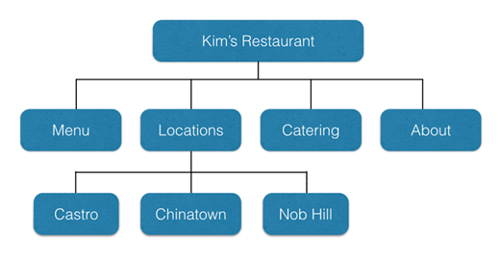

Website layout
You now need to list the items that will form your site’s layout. Begin with your landing page, as it is the first place that your site visitors are likely to visit, and then all following pages.

Homepage, About Page, Team Page etc.

Above the fold:

[Title]
[Logo] – (company logo)
[Headline] – (H1)
[Sub-headline] – (H2)
[Navigation bar] – (brand colors)
[Primary CTA] – (button)
[Sign up/login] – (button)
[Shopping cart] – (icon)

Below the fold

[Events] – (company photos)
[Blog articles] – (images)
[Industry trends]
[Press coverage]
[Location information]
[Trust indicators/reviews] – (icons)
[Benefits and/or features]
[Testimonials] – (customer photos)

Levels 2 and 3

[About]
[Gallery] – (company team photos)
[Products]
[Lead magnet- cheat sheet or whitepaper] – (Button)
[Blog]
[Comments]
[Social media – share buttons/links] – (active/inactive)
[FAQs]
[Contacts]
[Location information] – (Google Maps)
[NAP]

Style Guide
Style guides and pattern are essential to help the web designer maintain the structure and create experiences for our audience for various devices.

Resources

The main driver of resources is what you can do for them, what have you done so far, why should they choose, how you can help. Along with the style guide you need to create these messages across different methods that attract your audience the best.

List the resources that you will need to achieve the functionality that you intend. These include:
- Icons
- Fonts
- Videos
- Testimonials / Reviews
- Illustrations and graphics
- Marketing copy – white papers, press releases
- Images and their sources – company photos/stock

Navigation
Decide the navigation that you want based on your site structure, page layout, and features (both top and below-the-fold). It can be top, bottom, side or center. It can also be fixed (static) – where it does not change position with scrolling – or sticky (moves as the user scrolls).

